Step into Health and Social Care Programme

Leicester, Leicestershire and Rutland

Work Experience
Induction Booklet



Contents

PART A – Welcome and Induction 1
Introduction 1
Where do you need to report to and when? 1
What happens if you are sick? 2
What happens if you have an appointment e.g. dentist/doctor? 2
How will you know when to take breaks and lunch? 2
What happens if you hear a Fire Alarm or need to raise the Fire Alarm? 2
Upon discovering or suspecting a fire 3
What you should wear to your work experience 3
Security 4
Identification 5
Security Doors 5
Removing the Opportunity for Crime 6
Access to Computer Systems 6
Confidentiality 6
Confidential Information 6
Health and Safety 7
The Health and Safety at Work Act 7
See it, Sort it, Report it 7
Display Screen Equipment 8
Basic Principles of Safe Movement 8
Waste 8
Sharps 8
Slips, Trips and Falls 9
Spillages and Scalding 9
Smoking 9
Infection Control 9
Correct Hand Washing Technique 10
Our Values 11
Raising Concerns 12
How to raise a concern or a complaint 12
Support 13
PART B - Useful Information and Worksheets 14
Recognising Uniforms 14
Learning Styles 15
British Values 16
Safeguarding 17
Prevent Radicalisation 18
Modern Slavery 19
What is Modern Slavery? 19
What do I do if I have a concern about Modern Slavery? 19
Cyber Bullying 20
The effects of Cyber Bullying 20
Things you can do to prevent Cyber Bullying 20
What to do if you are Cyber Bullied 20
Looking After Yourself 21
Values and Behaviours 22
PART C – Careers in the NHS and the Health and Social Care System 23
Apprenticeships 24
Useful Career Links 25
https://www.instituteforapprenticeships.org/ 25
PART D - Work Experience Objectives 26
Where am I now? The skills, knowledge and behaviour scan 26
My Self-Assessment and Target 27
Placement Objectives; During my placement I hope to gain… 29
What is a Reflective Learning Journal? 30
My Learning Journal 31
Work Experience Placement Feedback Form to Student 35
Work Experience Student Evaluation Form 37

PART A – Welcome and Induction

Introduction

We would like to welcome you to our organisation which is part of the Leicester, Leicestershire and Rutland Health and Social Care System. We hope that you enjoy your work experience placement. You have been allocated a work experience placement supervisor and they will make every effort to support you during your time with us – feel free to ask them any questions and raise any concerns with them in the first instance. Your placement supervisor will also introduce you to the staff in the area you will be in.

This booklet has been devised to help you while you are on placement in the organisation in terms of information, things to look for and find out and space for you to write down and reflect on the things you have achieved while you are here. We will work with you to set, and support you in achieving, work placements objectives as well as help you gain an insight into the career opportunities open to you in health and social care.

You will have agreed the times and dates you are to attend when your placement was approved, however, if you are unsure please ask your placement supervisor to confirm these on your first day. Make sure you find out how to contact your placement supervisor, where to leave your coat and bag and where the toilets are located.

The Work Experience Induction Handbook has been split into 4 sections. All students should complete part A and discuss this with their placement supervisor. Please remember not to anything on your placement that hasn’t been agreed with your supervisor and ensure you are safe, and trained, to perform any tasks before you do so. Please utilise part B and C as much as you need to. Part D includes a number of useful tools for you and your placement supervisor to use including a placement feedback form which should be completed at the end of each day, and run through with your placement supervisor. This will help us to support you and make any tweaks to your programme that are needed to ensure you have the best experience possible.

If you have any questions about anything in this document then please ask. We hope you enjoy your placement.

Where do you need to report to and when?

Please arrive at the time and place you agreed when the placement was confirmed. You can add information on where and when you need to attend, and who your supervisor will be, below if you wish too.
Site e.g. LRI | Location  e.g. Department and room. Remember health and social care organisations can be complicated places so make sure you get clear directions. | Name – note who you are to as for | Contact number – in case you can’t find them and need to call

What happens if you are sick?

If for any reason you are unable to attend on any of your planned days, you must notify your placement supervisor as early as possible on the morning of the absence. They will record your absence and check you are ok. If you are on a programme with the Princes Trust please also inform your Princes Trust lead contact of your absence.

What happens if you have an appointment e.g. dentist/doctor?

If you have any appointments you need to attend during your work placement please ensure you inform your placement supervisor as soon as you know so that they can plan your visit around them wherever possible.

How will you know when to take breaks and lunch?

We have restaurants at all the hospital sites where you can buy, sit and eat food. There are also a variety of shops to purchase food and drinks from. Your placement supervisor will direct you to the nearest one. This may vary in other health and social care organisations so please check and bring food/drink as required.

The areas you are being hosted in may also have a staff room which may have some facilities to warm up food or make drinks. Remember to either bring a packed lunch or money to purchase lunch and refreshments at one of the restaurants or shops on site.

At your induction make sure you ask what the procedures are for taking your lunch and making a drink so you feel comfortable doing so. It is important to know that using your personal phone will be restricted to break times also to help you get the most out of your placement.

What happens if you hear a Fire Alarm or need to raise the Fire Alarm?

Firm alarms mean different things. Make sure you know what to listen for

An intermittent bell ringing tends to means that the fire alarm has been raised within the zone or area where you are and is a warning of possible evacuation. Please ensure you follow the guidance from the manager in the area who will update you if you need to evacuate.

A continuous bell ringing tends to means that the fire alarm has been raised within the department or area you are working in. The manager of the area will ensure you evacuate as needed. Please do not return to collect personal belongings.

Upon discovering or suspecting a fire

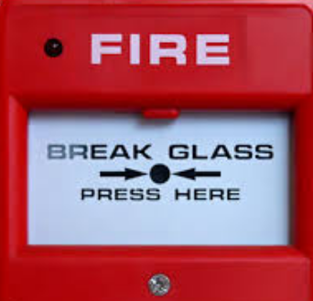
Do!
- Sound the alarm by breaking the glass in the nearest fire alarm call point
- Ensure no-one is in immediate danger
- Close doors near to the fire to prevent fire spread
- Attack the fire using the fire equipment, but only if it is safe to do so
- Report details to the Senior Person present. Find out what emergency number you need to ring e.g. If you are at University Hospitals of Leicester you call extension 2222 yourself if you are alone when discovering the fire on your way to your placement department for example.

Do Not!
- Use the lifts, as power may be lost
- Stop to collect belongings
- Return until it is safe to do so.

The Fire Safety meeting point during my placement is…
I know where to find the fire doors

I know where the fire alarm is

What you should wear to your work experience

Dress should be acceptable and safe for the environment that you are working in. All clothing must be of a suitable design to allow unrestricted movement during possible moving and handling. The health and social care organisations are multicultural and are supportive of religious dress. You placement supervisor will make you aware of any specific requirements which may apply to your work area. The organisation has a dress code and it is suggested that during your placement acceptable dress would include items from the green list below. NB: When you are in the organisation you may observe staff not adhering to the dress code standard. Whilst this isn’t a desirable state please do not lower your dress to align with this. You are developing and working on your employability skills during your placement and by adhering to the outlined standards you will be promoting your professional self.

Acceptable / Suggested Dress  NB: Please do not buy anything specially – please wear the closest you have to the below. | Unacceptable Dress
Smart black trousers, skirt or culottes | Leggings, jeans, jogging bottoms or shorts
White top, blouse, shirt  NB: If you choose to wear a long sleeve shirt or top please be aware that in some areas you may be requested to roll up the sleeve to the elbow | Slogans, cut-outs or vests
Shoes must comfortable to wear and appropriate for the department and role – hospitals are big places and there may be a lot of walking involved | Open toe sandals, high heels, platforms, trainers or flip-flops
Long hair should be tied back and beards and moustaches should be neatly trimmed | Untidy or dirty hair
Jewellery can be worn but it should be limited to wedding bands and suitable small earrings | Nothing of high value is recommended (cost or sentimental)
Nail polish can be worn in certain areas | Nail polish cannot be worn in certain areas

Security

The security of organisations vary however there will be procedures you need to find out about and follow during your work placement. The organisation, its property and that of staff, patients and visitors is a high priority and while you are here on placement we need it to be a high priority for you too. It is everyone’s responsibility to ensure the security of personal property. Similarly, we all share the responsibility to safeguard the organisation, please remember to:

- Lock offices
- Close windows
- Wear your identity badges
- Look after personal property
- Lock outside doors behind you, if necessary.

If you see something that concerns you please report it immediately. Security can be contracted on ……………………. (please insert for your organisation)
e.g. University Hospitals of Leicester
LRI | Ext 6767
LGH | Ext 4292
GH | Ext 2999

Identification

On starting your placement you will have had a series of identity checks and signed a confidentiality form. This will enable you to be issued with an identification badge (ID) relevant to your placement on your first day. This MUST be returned at the end of your placement.

You must wear this at all times when in the organisation and it must be clearly visible. If you do not wear your badge you may be challenged on your identity by staff and security. Staff are expected to professionally challenge any strange faces in their area if they aren’t known to them; please don’t be offended, or embarrassed, if someone stops you and checks who you are, they are just asking to make sure that we keep ourselves, patients and their families’ safe whilst in our care. You must always wear your identity badge but if you have any problems, please ask a member of staff to confirm your identity with your placement supervisor.

Please return it to your placement supervisor on the last day of your placement. You are not allowed to keep it after the placement has ended.

If your host department has issued you with a ‘staff’ style ID badge to support the type of placement you are on this may also allow you to travel on the Leicester hospital hopper for free. This means that you may be able to travel to the hospital sites or between sites if you need to without additional cost. An up to date timetable will be provided by your placement supervisor if required for the placement.

You must look after your badge at all times however if you are unfortunate enough to accidentally lose it or have it stolen please inform your placement supervisor immediately so they can take the appropriate security actions.

Security Doors
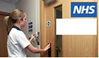
There are security doors situated at the entrance to some areas of organisations. These doors often have a keypad system, card swipe access or buzzers to gain access.

You must never hold a door open and let anyone in and if confronted you should politely ask that they wait and notify another member of staff in the department team.

You should also never ‘tailgate’ into an area so if there is a door swinging open don’t be tempted to follow someone into the area. Follow the correct procedures to access the area and people you need. If you are given any door access codes do not give them out

Removing the Opportunity for Crime
Many thefts are committed by the opportunists who walk the corridors of health and social care buildings looking for the easy target. Make sure you follow the guidelines your placement supervisor sets and keep safe/lock away personal items while you are here.

Access to Computer Systems

You will be given relevant access to the systems you need, if you need them, during your placement for the term of your placement. Always lock PC’s when leaving them and never share your password or let someone else use the computer when you are logged in. Any IT accounts will be disabled on your last day.

Confidentiality


Whilst you are on placement you may see confidential information about patients and their families, members of staff or other health service business. You are not allowed to discuss or share this outside of the parameters of the placement.

This means that for example if you see your Mums best friend in the hospital corridors you aren’t allowed to tell Mum or anyone else that you have. If you know your football friend comes to the hospital for a hurt ankle you aren’t allowed to look for their medical records. If you come across the medical information for your cousin during your placement you aren’t allowed to say that you have seen it or what was in it.

When you agreed to take the placement on you will have signed a confidentiality agreement. You must ensure you understand what it means and adhere to it.

You should note share confidential information and details about the placement on your personal social media. You should not take pictures or videos during your placement unless you have agreed these with your placement supervisor. Please read the information below and clarify any details you are unsure about with your placement supervisor.

Confidential Information
‘Confidential information’ means all information of a confidential or exclusive nature including but not limited to information relating to patients and staff.

Work Placement Students should:
- Not disclose any confidential information to a third party including but not limited to the media, friends and relations, without formal approval
- Only disclose confidential information to a member of staff with a valid ID badge, who is doing work on behalf of the organisation, where telling them the information is necessary for them to do their job and you are allowed to access and disclose the information as part of your placement
- Not discuss confidential information outside the organisation, when travelling on the hospital hopper or public places
- Not copy, or photograph, any confidential information outside what you are asked to do as part of your placement. This work will be left with the staff member requesting it and you will not keep a copy yourself
- When someone gives you confidential information, ensure it is kept safe and not left on display or left available for anyone who is not authorised to see it or access it
- Only use confidential information for the purposes for which it was acquired
- Failure to observe this rule may lead to formal action being considered.

Health and Safety

All citizens are responsible for taking reasonable care for the health and safety of themselves and others. This is no different while you are on placement. If you have a concern, even if you aren’t sure it is a valid concern speak up. We would rather you tell us now than hear after it happened that you wondered if it was a risk.

Health and Safety covers a number of topics. We have added some brief information about the core ones below however please discuss with your placement supervisor in more detail depending on the area you are in and its risks. Do not use equipment during your placement that you have not been trained to use. You should be supervised when using equipment at all times.

The Health and Safety at Work Act
Duty of employers is to ensure health, safety and welfare of employees by provision of safe systems of work, provision of training and supervision.

Duty of employee to take reasonable care for health and safety of yourself and others and co-operate with employer to enable act to be complied with.

See it, Sort it, Report it

See it…
If you become aware of a Health or Safety risk to yourself or others you must take action
Where there is serious and imminent danger you must make safe, stop the activity and seek urgent advice The Health & Safety team who can be contacted on 0116 2583386.

Sort it…
Can you deal with the issue? Do you have the required competence?
Can you take action to remove or reduce the risk to an acceptable level?
If you can you should take the necessary action to prevent harm to yourself or others.

Report it…
If you cannot deal with the issue you must report the issue to an appropriate person – your placement supervisor for instance - who will decide on a way forward and report the situation.

Display Screen Equipment
Using screens is very common in modern times however our posture, position and eye sight are important and should be looked after.

Basic Principles of Safe Movement
While you are on placement the amount of moving should be very limited however if you do have to move something make sure you know how to, and are trained to, first. Some key points to remember are:

- If it’s not necessary to move the load, then DON’T do it
- Slide rather than lift (See if you can observe how the nurses use slide sheets to move patients if you are on a ward)
- Assess the load before moving and handling and prepare your environment to ensure safety at all times

- Have a steady base feet apart, keeping knees bent and relaxed
- Don’t bend, twist or stretch (repeated movement can cause back problems)
- Use rhythm and timing to make a move
- Move in stages keeping the load close
- Keep the natural ‘S’ curves of your spine as much as possible
- Ensure you are trained to move that type of load.

Waste

Organisations are regulated with how they manage waste. Please ensure you know how to safely dispose of items properly during your placement. Find out what you need to throw away in which bin for the area you are on placement in.

Sharps

Health and Social Care organisations often deal with needles so they have special bins to put sharps (needles) in. However on very rare occasions these may find their way into rubbish bags. If you spot one, or on the incredibly rare chance get scratched by one please report it immediately to your placement supervisor who will follow the required safety procedures. Do not attempt to pick a needle up if you see it lying around. Report it.

Slips, Trips and Falls

Become familiar with the environment you are on placement in. Whilst there shouldn’t be anything to trip over, and there shouldn’t be any loose tiles or wires it is important you know you are safe and prevent any slips, trips or falls for yourself and others.
Do not run; especially inside the building. This will help reduce your risk of slipping, tripping and falling.

Spillages and Scalding

Be very careful when carrying hot drinks. Do not overload trays. Do not use stairs when carrying hot drinks. Do not overfill cups. If you spill some of your water or tea, or if you spot a spillage on the floor don’t ignore it. Ask your placement supervisor immediately how it needs to be cleaned it. It is important to check and get the trained staff to resolve the spillage especially if it is a spillage you have come across as it could be an infection risk or a hazardous chemical that has leaked. Placement students are not expected to work with any chemicals. Any chemicals in the area you are in placement in should be appropriately stored and disposed of in line with COSHH (Control of Substance Hazardous to Health). Clinical areas will have specialist spillage kits with staff trained to use them. Do not touch these items unless you are trained and safe to do so.

We can’t just plug chargers and electrical equipment in at the organisation without it undergoing a safety check called a PAT test. Please therefore ensure that you have any electronical items you bring with you on a placement fully charged before you arrive.


Smoking

The organisation has a No Smoking Policy, for everyone, smoking is not permitted anywhere within the Hospital or grounds. If you do smoke ask your placement supervisor where this is allowed.

Infection Control

The control of infection in hospital is extremely important. Here are some general hospital guidelines for infection control:
- Wash hands or use alcohol gel (clean hands) when coming into and leaving the department
- Clean hands when entering or leaving any clinical area e.g. wards
- Wear any protective clothing (PPE) as required and remove/dispose this in accordance with the guidelines
- Follow the handwashing guidance.

Correct Hand Washing Technique

Hand washing is simple but one of the most effective means of protecting patients and staff from infection.

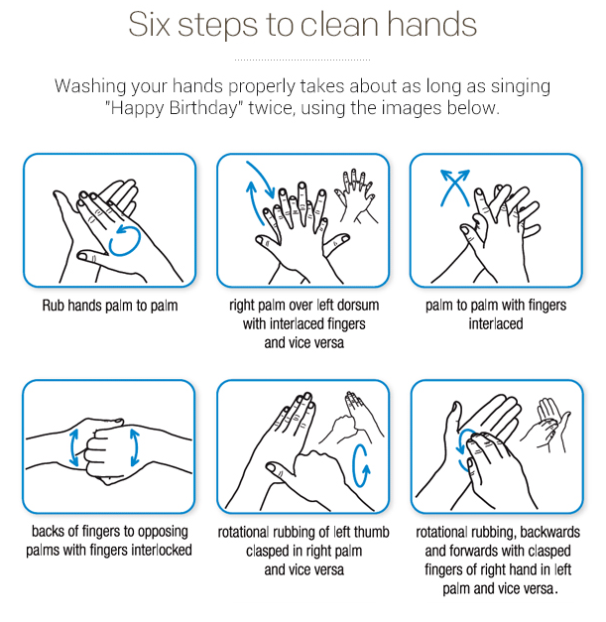
https://vimeo.com/161770151

Our Values

Organisations will have different values. Below are the ones for University Hospitals of Leciester. Please find the ones for your organisation. Values are often developed by talking to patients, staff and the community to design how things should be done. This helps us look at what we do e.g. send a letter out, plaster a broken arm, clean a ward, cook a meal and how we do it.
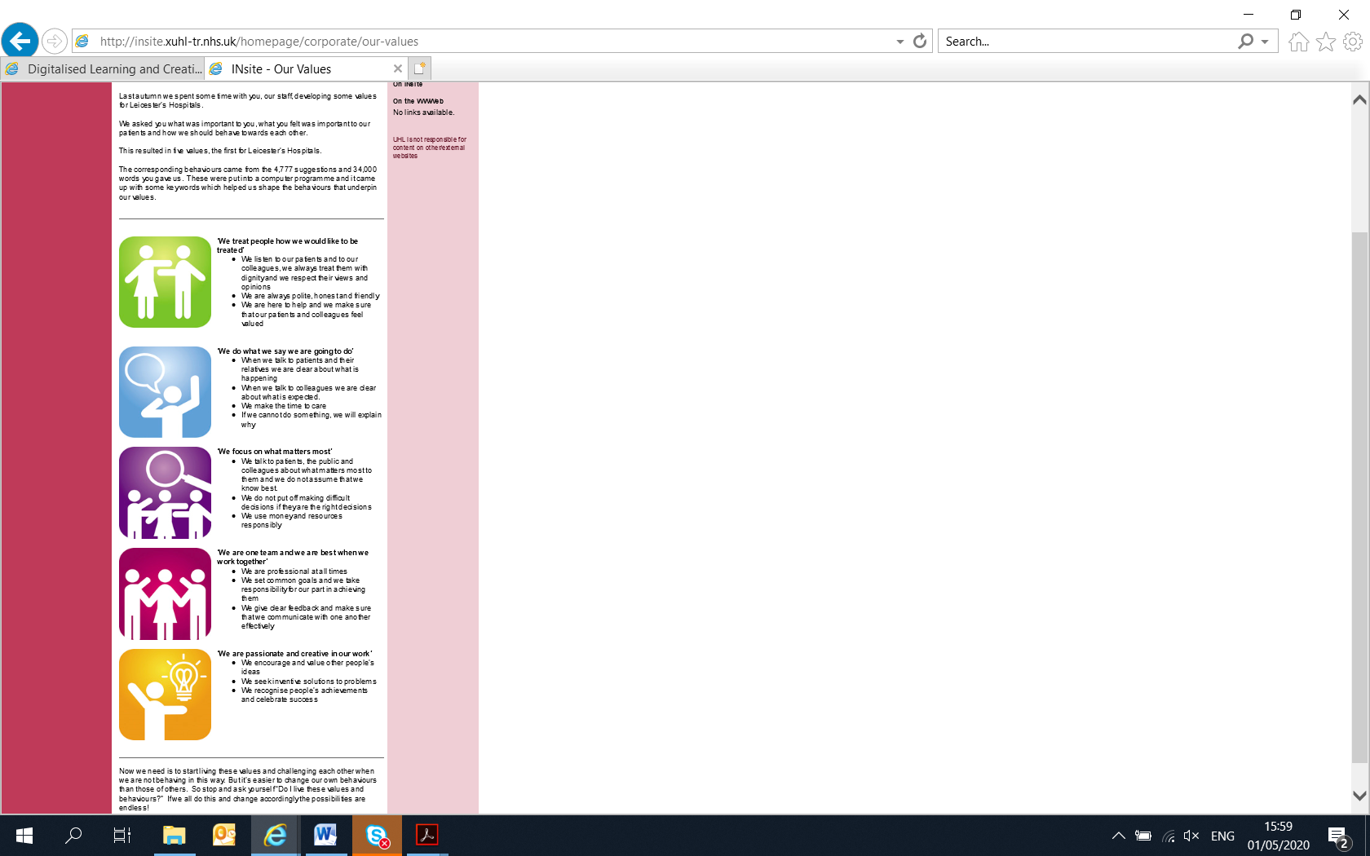
‘We treat people how we would like to be treated’
- We listen to our patients and to our colleagues, we always treat them with dignity and we respect their views and opinions
- We are always polite, honest and friendly
- We are here to help and we make sure that our patients and colleagues feel valued
‘We do what we say we are going to do’
- When we talk to patients and their relatives we are clear about what is happening
- When we talk to colleagues we are clear about what is expected.
- We make the time to care
- If we cannot do something, we will explain why
‘We focus on what matters most’
- We talk to patients, the public and colleagues about what matters most to them and we do not assume that we know best.
- We do not put off making difficult decisions if they are the right decisions
- We use money and resources responsibly
‘We are one team and we are best when we work together’
- We are professional at all times
- We set common goals and we take responsibility for our part in achieving them
- We give clear feedback and make sure that we communicate with one another effectively
‘We are passionate and creative in our work’
- We encourage and value other people’s ideas
- We seek inventive solutions to problems
- We recognise people’s achievements and celebrate success

Raising Concerns

- If you have a health and safety concern please raise it with your placement supervisor or a senior person in the department as soon as practically possible
- If you came across a fire ring extension ………..(insert for your organisation) e.g. University Hospitals of Leicester is x2222
- If you came across someone collapsed in a corridor ring extension ………..(insert for your organisation) e.g. University Hospitals of Leicester is x2222
- If you need to raise a concern about your placement email LLRworkexperience@uhl-tr.nhs.uk
- If you need to raise a formal potential or actual safety concern, contact the Freedom to Speak Up Guardian………..(insert for your organisation) e.g. University Hospitals of Leicester is Freedom2speakup@uhl-tr.nhs.uk.
You can raise concerns about risk, malpractice or wrongdoing where you think there is harm or potential harm to the patients cared for by the organisation. Some examples of this could be:
- Unsafe patient care.
- Unsafe working conditions
- Inadequate induction or training for staff or volunteers
- Lack of, or poor, response to a reported safety incident
- Suspected fraud, which can also be reported to the Counter-Fraud Team
- A bullying culture (across a team or organisation. Individual instances of bullying will be processed under the Anti-Bullying and Harassment Policy).

Concerns raised will be taken seriously and investigated as appropriate. The organisation will not tolerate the harassment or victimisation of anyone raising a concern. However, it is recognised that an individual may have good reasons to raise a concern in confidence and their identity will not be disclosed without their consent (unless disclosure is required by law). Our Freedom to Speak up Guardian promotes the ‘Freedom to Speak up’. The role of the guardian is to act in an independent capacity, to support the organisation to become a more open, transparent place and to listen and support all to raise concerns.

How to raise a concern or a complaint
Ideally raise it with your placement supervisor immediately.
You can however also raise it as below:
- Dial extension………..(insert for your organisation) e.g. University Hospitals of Leicester is 3636; this is the Staff Concerns Reporting Line. It is a voicemail service which allows us to report issues that we believe may affect the quality and safety of patient care
- If the concern is about fraud or corruption, speak in confidence too………..(insert for your organisation) e.g. University Hospitals of Leicester is 01509 604029 neil.mohan@nhs.net , or 01223 552333 g.lekh@nhs.net or 01603 883099 juliette.meek@nhs.net NHS confidential fraud and corruption reporting line on 0800 0284060 and www.reportnhsfraud.nhs.uk
- Call our confidential Anti-Bullying and Harassment Adviser Service on 0116 258 8096 if you have been personally affected or have witnessed it. You can also email the Equality, Diversity and Inclusion team for advice and support on ………..(insert for your organisation) e.g. University Hospitals of Leicester is equality@uhl-tr.nhs.uk or the UHL BAME (Black, Asian and Minority Ethnic) Voice Network BAMEVoice@uhl-tr.nhs.uk or the UHL DAV (Differently Able Voice) Network DifferentlyAbleVoice@uhl-tr.nhs.uk
- To receive confidential advice and support contact the Freedom to Speak up Guardian directly on ………..(insert for your organisation) e.g. University Hospitals of Leicester is: Tel: 0116 2502740 Mobile: 07950839130.
If you have a complaint or concern about your placement and you don’t feel able to discuss it with your placement supervisor please email llrworkexperience@uhl-tr.nhs.uk.
If you don’t get a satisfactory response to your placement complaints within 5 working days please be aware that as placements are monitored through Work Experience Quality Standards you are also able to escalate your complaint by email to the complaint to Fair Train complaints@fairtrain.org.

Support

If you have questions, feel upset or concerned by anything you have seen whilst on your work placement please contact your placement supervisor in the first instance to discuss and they will help and support you.
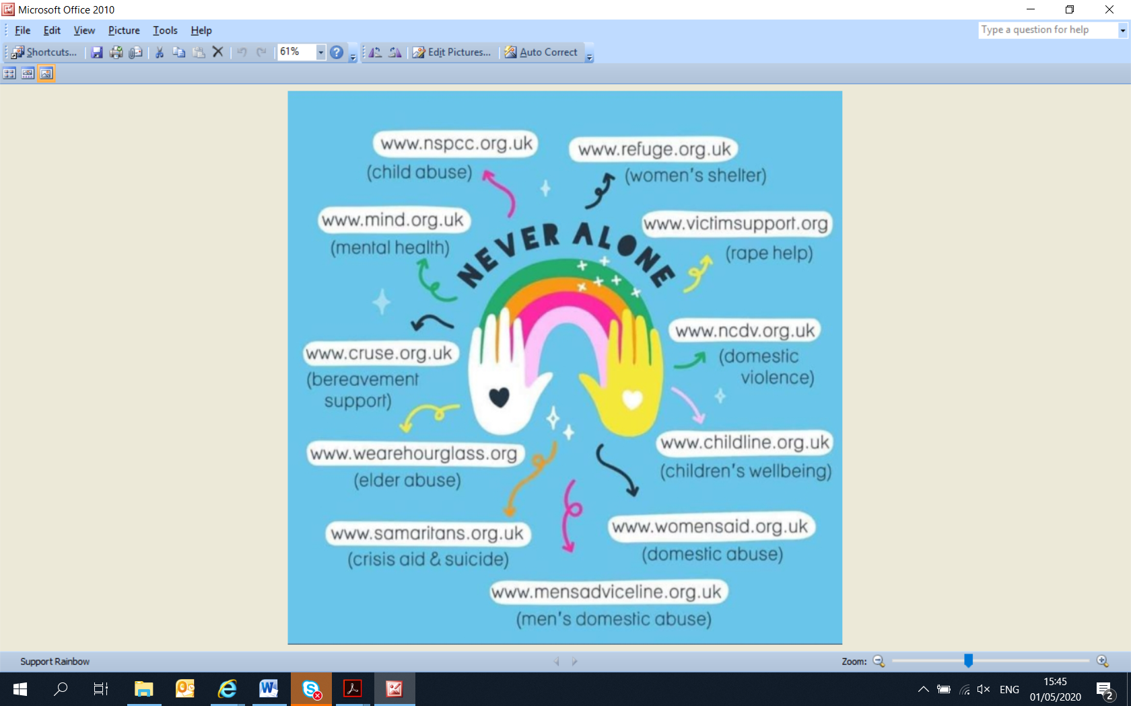

PART B - Useful Information and Worksheets

Recognising Uniforms

During your time working in your areas you will meet many job roles, not everyone will be in a uniform but they all play a vital role in in patient care. Here are example uniforms for example that NHS staff in Leicester Hospitals wear.
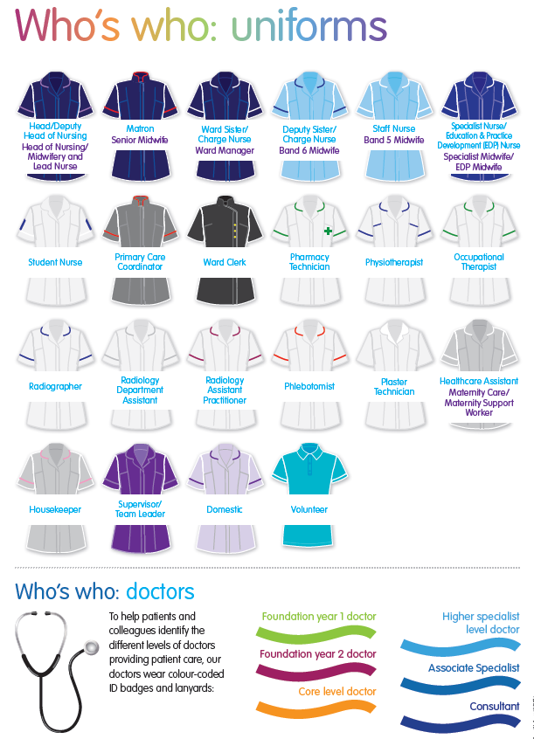

Learning Styles

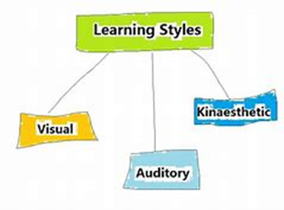

We all learn in different ways. Some of prefer reading, some having a go. If you want to find out your preference have a go at the learning style questionnaire on http://vark-learn.com/the-vark-questionnaire/

- What is your preferred learning style?

- When do you learn best?

- When do you find it hardest to learn?

- What can you do or what do you do to overcome this?

British Values

Have you heard of British Values? Do you know how they relate to us at home and work? Have a look at the film. You will need somewhere quiet to view it and a computer that plays sound. It should take about 20 minutes. https://www.youtube.com/watch?v=KUMvvDE5yI4
- Which British Values link to the bubbles below? Jot down the British Values in the bubbles and link them to the examples in the rectangle boxes. Are there any missing? If so which?
1.

Work together and help and support one another
Respect one another
Respect others contributions to discussions and activities

2.

Develop fair rules for the classroom

3.

We make our own choices and understand the rewards / consequences of our own actions

4.

Learners have a say in what happens / involvement / learner rep groups , feedback and evaluations recorded and listened to etc.

Safeguarding


- Do you know what Safeguarding is? Talk to your placement supervisor to understand the different types of abuse and how to raise a concern. If you have had a personal experience of this please do not feel under any obligation to disclose it however if you feel you need support do let your placement supervisor know.

- 2. What are the 4 types of Child Abuse?

1
2
3
4

- What are the 9 types of Adult Abuse?
1
2
3
4
5
6
7
8
9

- What would you do if you had a safeguarding concern about something you had seen on your placement? Do you know you can raise any personal concerns with us too while you are on placement and we will support you the next steps for these.

Prevent Radicalisation

- What is Prevent? Talk to your placement supervisor to understand Prevent and how to raise a concern.

- Why do we have it?

- What signs would you look out for or what you might notice in someone who may be being exploited and radicalised could be changes to normal behaviour?

- How would you raise a concern on radicalisation and who to?

Modern Slavery

What is Modern Slavery?
Modern slavery is the severe exploitation of other people for personal or commercial gain. Modern slavery is all around us, but often just out of sight. People can become entrapped making our clothes, serving our food, picking our crops, working in factories, or working in houses as cooks, cleaners or nannies.
From the outside, it can look like a normal job. But people are being controlled – they can face violence or threats, be forced into inescapable debt, or have had their passport taken away and are being threatened with deportation.
The free Unseen App gives you a short guide to spotting the signs in your pocket, and enables you to report at the click of a button.
Modern slavery takes many forms. The most common are:
- Human trafficking. The use of violence, threats or coercion to transport, recruit or harbour people in order to exploit them for purposes such as forced prostitution, labour, criminality, marriage or organ removal.
- Forced labour. Any work or services people are forced to do against their will under threat of punishment.
- Debt bondage/bonded labour. The world’s most widespread form of slavery. People trapped in poverty borrow money and are forced to work to pay off the debt, losing control over both their employment conditions and the debt.
- Descent–based slavery. Most traditional form, where people are treated as property, and their “slave” status was passed down the maternal line.
- Slavery of children. When a child is exploited for someone else’s gain. This can include child trafficking, child soldiers, child marriage and child domestic slavery.
- Forced and early marriage. When someone is married against their will and cannot leave. Most child marriages can be considered slavery.
https://www.antislavery.org/slavery-today/modern-slavery/

What do I do if I have a concern about Modern Slavery?
The good news is anyone can play a part in stamping out exploitation. Keep a look out for the signs of slavery described below, and call the Modern Slavery Helpline or report online if you see anything amiss.

Cyber Bullying
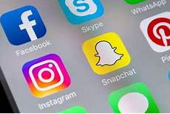

Cyberbullying in the workplace, or learning environment, can not only affect the individual when they are working/learning but it can also affect their home life as you cannot leave social media e.g. WhatsApp, at work – it follows wherever you go

The effects of Cyber Bullying

Cyberbullying can make a person feel very anxious when they are work because they may have fears for the safety and wellbeing but they could also become depressed from the continuous harassment.

https://youtu.be/-bhrqQ5zNmc

Things you can do to prevent Cyber Bullying

- Know what is acceptable and what you should do if you have any concerns
- Regularly check your privacy settings on all your social media to ensure they are up-to-date
- Know who you would go to if you had a concern
- Know how to raise concerns
- Understand the British Values
- Have open discussions at home, with friends and in learning on what it is to raise awareness, fears, concerns and swop knowledge and skills on your understanding, privacy settings and policies etc.

What to do if you are Cyber Bullied

Talk to someone as soon as you can – you do not need to, and shouldn’t have to, go through this alone. https://www.familylives.org.uk/ , helpline 0808 800 2222, askus@familylives.org.uk
.

Looking After Yourself

  - What does healthy eating mean to you?

  - Name 5 different things you could have as part of your 5 a day?

  - Why is exercise good for us? How much should we aim to do a week?

  - Which organ in the human body could be badly affected by alcohol?

  - Match the 8 products up to the 4 categories

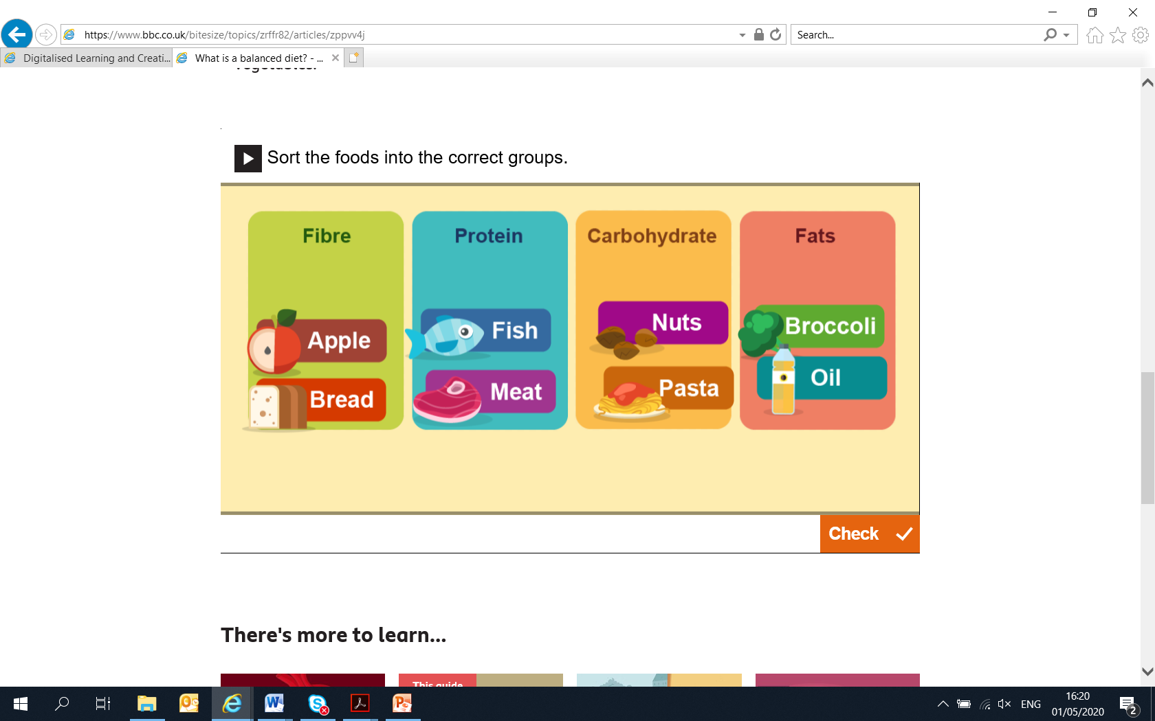

Values and Behaviours

  - During your work placement describe an example of where you saw someone demonstrated ‘We treat people how we would like to be treated’ (key things to look for is how well did they listen, did they treat the person with respect, were they friendly, honest and polite?)

  - During the placement can you think of an example of where you have demonstrated the value ‘We do what we say we are going to do’?

  - ‘We focus on what matters most’ could ink to how we use money and resources. From what you have observed are there any improvements that could be made that you saw during your placement?

  - We give clear feedback and make sure that we communicate with one another effectively is an example of the behaviour we could use to demonstrate ‘We are one team and we are best when we work together’. Was feedback you received during your placement helpful to you knowing what you were doing well and how you needed to do things differently? Share your thoughts.

5. ‘We are passionate and creative in our work’ – what did you observe in your placement on this value?

PART C – Careers in the NHS and the Health and Social Care System

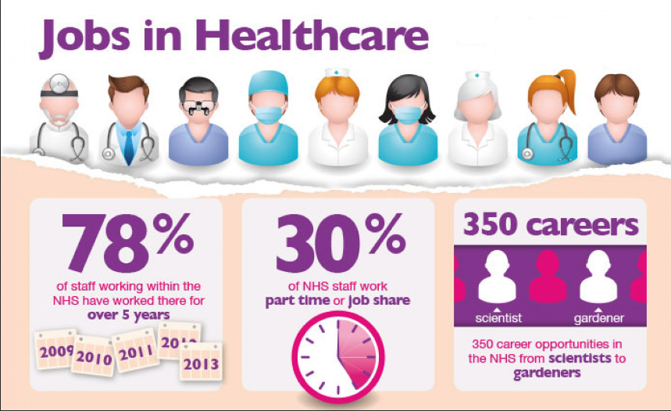

There are so many different careers in the NHS, over 350 in fact, never mind the whole health and social care system. If you aren’t sure which one is for you spend 5 minutes doing this quick quiz https://www.healthcareers.nhs.uk/FindYourCareer

What did it come up with?
Does this sound like something you would like to do?
Did you know about it before taking the quiz?
How can you find out more on something that you are interested in doing for your career?
What qualifications do you need to start this career? How can you get these?
Have a chat with your placement supervisor about what would found out.

Apprenticeships
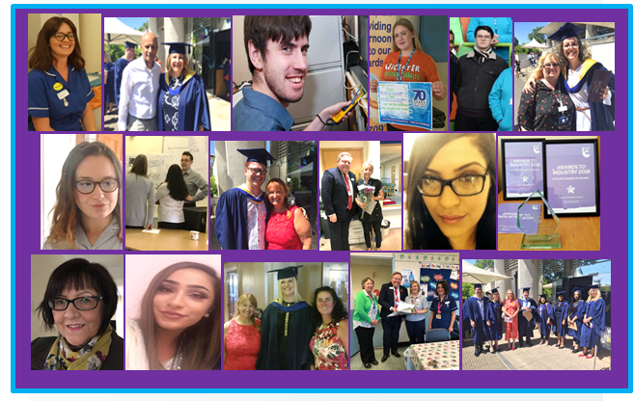

Apprenticeships provide routes into a variety of health and social care careers from level 2 to level 7. You might join us as an intermediate apprentice doing level 2 customer service role in one of our clinics or corporate departments, an advanced level doing level 3 Business Admin in a clinical or non-clinical area or at degree level as a Health Care Scientist. Our existing staff also complete apprenticeship programmes to develop themselves too. All the course fees are paid through the Government levy which means there is nothing to pay back and you would earn a wage while you are learning! Completing an apprenticeship means you have a nationally recognised qualification. For example a level 2 apprenticeship is the equivalent of completing 5 GCSE’s, a level 3 is equivalent to 2 A levels! So when you apply for a job in the future and it asks if you have 5 GCSE’s or equivalent, a completed level 2 apprenticeship means that you can say yes. You will also be supported during the apprenticeship to complete maths and English if you don’t leave school with them – but don’t worry learning these isn’t like doing them at school! You are taught things you need in everyday life in an adult environment. This is brilliant for your CV as you can once again tick that box when it says do you have maths and English at GCSE level or equivilent.
Level | Equivalent to… | Referred to as..
2 | 5 x GCSEs | Intermediate Apprenticeship
3 | 2 x A levels | Advanced Apprenticeship
4 | Year 1 of a Degree | Higher Apprenticeship
5 | Foundation Degree | Higher Apprenticeship
6 | Degree | Degree Apprenticeship
7 | Master Degree | Degree Apprenticeship
Apprenticeships are an excellent opportunity to earn, gain work experience and achieve nationally recognised qualifications at the same time.
Apprenticeships are offered by individual employers in many different areas of work.
Below are some examples of apprenticeships that we have at Leicester’s Hospitals.
Health and Science
Healthcare support worker L2
Senior Healthcare support worker L3
Healthcare Assistant practitioner L5
Nursing Associate L5
Registered Nurse Degree L6
Mammography Associate L4
Pharmacy Services L2
Pharmacy Technician L3
Healthcare Science Associate (Medical Equipment) L4
Healthcare Science Practitioner Degree (Biomedical Science, Physiology, Cardiology, Respiratory, Radiotherapy) L6
Administration and Management
Assistant Accountant L3
Accountancy/Taxation Professional L7
Assessor/Coach L4
Associate Project Manager L4
Business Administration Framework L2
Business Administrator L3
Customer Services Practitioner L2
Customer Service Specialist L3
Data Analyst L4
Improving Operational performance Framework L2
Team Leader Framework L2
Team Leader/Supervisor L3
ILM Operations/Departmental Manager L5
Chartered Management Degree Apprenticeship L6
Senior Leaders Master’s Degree L7

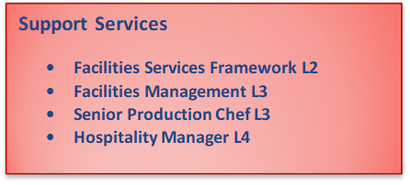

Useful Career Links
https://www.healthcareers.nhs.uk/FindYourCareer
https://www.jobs.nhs.uk/
https://www.your-future.co.uk/
https://www.stepintothenhs.nhs.uk/apprenticeships
https://www.healthcareers.nhs.uk/explore-roles
https://haso.skillsforhealth.org.uk/

https://www.instituteforapprenticeships.org/
www.gov.uk/apprenticeships-guide/overview
Support Services
Facilities Services Framework L2
Facilities Management L3
Senior Production Chef L3
Hospitality Manager L4

www.apprenticeshipguide.co.uk/what-is-an-apprenticeship/
www.acas.org.uk/apprentices
www.nsahealth.org.uk

PART D - Work Experience Objectives

Placement logs can be found below for you and your placement supervisor to complete during your time in the workplace.

It is not always possible to complete them every day however we do suggest that you complete them as often as possible. It is good for you to reflect on how you are progressing and what you are learning.

It is recommended that you and your placement supervisor set objectives for things you would like out of your placement on the first day and then revisit this, at least once, during the placement to see how you are getting on and then formally review your learning and progress at the end of the placement.

Where am I now? The skills, knowledge and behaviour scan

- Please mark the relevant box with a ‘X’ using the scale where 0 is ‘not at all’ and 5 is ‘excellent – nothing I could do better’
- If you are less than a 5 and you want to, hope to, develop this skill during your work experience placement please think about the target score you would like both during your time here and overall for you as a person. These will likely be different as your placement may only be for a short space of time in which you may start to develop something however may need more time to continue to develop it after the placement ends
- At the end of your placement please revisit this and mark with a ‘O’ where you score yourself. This will identify your progress.

Example of what it could look like at the end of your placement
Workplace Skills | 0 | 1 | 2 | 3 | 4 | 5 | Target during placement | Target for me
Able to interpret instructions |  |  |  | X | O |  | 4 | 5
Know how to use a photocopier | X |  |  | O |  |  | 5 | 5
Know how to use a landline phone; including the hold and transfer facility |  | X |  |  |  | O | 5 | 5

My Self-Assessment and Target
Personal Qualities | 0 | 1 | 2 | 3 | 4 | 5 | Target during placement | Target for me
Attitude
Commitment
Motivation
Self confidence
Responsible
Personal appearance
Friendly
Reliability
Attendance
Punctuality
Resilience
Manage personal stress and anxiety
Help others
Assertive
Workplace Skills | 0 | 1 | 2 | 3 | 4 | 5
Able to speak up and raise a concern
Able to hold a professional conversation
Know how to phrase a professional email rather than a personal one
Know how to use a keyboard and PC
Able to interpret instructions
Able to follow own initiative
Able to follow directions
Able to read and understand at a level relevant to age
Able to solve simple problems
Able to conduct simple numeracy work e.g. percentages, addition, multiplication and subtractions.
Able to problem solve
Know how to use the internet
Know how to use a photocopier
Know how to use a landline phone; including the hold and transfer facility
Interpersonal Skills | 0 | 1 | 2 | 3 | 4 | 5
Able to interact with supervisors and senior staff
Able to interaction with staff in the team
Feel comfortable interacting with the general public e.g. Patients, Visitors and Customers (internal and external)
Able to co-operation
Able to accept positive feedback
Able to accept and know how to act on developmental feedback
Reflect
The 3 things I am strongest at are…

The 3 things that I feel the least strong with are…

The 3 things that I feel will help me the most if I develop in them are…
(These may not be the 3 things you are least strong in. It could be that by making things you are good at even better it will help you)

Comments

Placement Objectives; During my placement I hope to gain…
Consider what you would like to learn, develop or experience under the following headings. They may not all feel relevant so pick ones that are. |  | I would like to develop/learn or experience… | I will know I have been successful in doing this because… | The help and support I think I will need to do this is…
About the NHS

About the specialty, profession or department
About the role

About me | Personal Qualities
About me | Workplace Skills
About me | Interpersonal Qualities

What is a Reflective Learning Journal?

A Reflective Learning Journal is a log which evidences your own learning and skills development. It is not just a diary or record of “what you have done”, but a record of what you have learned, tried and critically reflected upon. It is a personal record of your own learning. As such it is a document which is unique to you and cannot be ‘right’ or ‘wrong’. A Reflective Learning Journal helps you to record, structure, think about, reflect upon, plan, develop and evidence your own learning.
For example, if in your Learning Journal you include details of what you did or how you did something then consider asking yourself questions such as:
- What did I do..
- Did it go well? Why? What did you learn?
- Did it go badly? Why? What did you learn?
- How can you improve the experience for the next time?

A Learning Journal contains your record of your experiences, thoughts, feelings and reflections. One of the most important things it contains is your conclusions about;
- The overall experience
- How what you have learnt is relevant to you and how you will use the new information / knowledge / skill / technique in the future.

It may contain:
- Details of problems you have encountered and solved (or not solved).
- Examples of where you have started to try out and practice a new skill
- Any on job experiences where you feel you have performed or managed them well or not
- Examples of any formal or informal training / learning you have undertaken either on or off the job

Remember - The log should be relevant to you and your job / studies / role / activities. (www.knowledge.scot.nhs.uk) Leading for the Future, 2013)
On the following pages there are 3 learning journals for you to complete. If you need more please do copy some.

My Learning Journal
Reflection Number 1: Date
What happened? (Provide a detailed reflection of the event)

Based on your actions what happened? (provide a detailed reflection of your actions and the impact they had)

What did you learn as a result?

What will you do differently in the future?

What further learning needs did you identify?

How and when will you address these?

Comments: If your placement supervisor or another member of staff was present ask them to write on a separate piece of paper a bit about it too, read through this. What are the key points in it? These ‘witness testimonies’ help us to see a situation from another’s point of view which may in itself provide additional learning.

Reflection Number 2: Date
What happened? (Provide a detailed reflection of the event)

Based on your actions what happened? (provide a detailed reflection of your actions and the impact they had)

What did you learn as a result?

What will you do differently in the future?

What further learning needs did you identify?

How and when will you address these?

Comments: If your placement supervisor or another member of staff was present ask them to write on a separate piece of paper a bit about it too, read through this. What are the key points in it? These ‘witness testimonies’ help us to see a situation from another’s point of view which may in itself provide additional learning.

Reflection Number 3: Date
What happened? (Provide a detailed reflection of the event)

Based on your actions what happened? (provide a detailed reflection of your actions and the impact they had)

What did you learn as a result?

What will you do differently in the future?

What further learning needs did you identify?

How and when will you address these?

Comments: If your placement supervisor or another member of staff was present ask them to write on a separate piece of paper a bit about it too, read through this. What are the key points in it? These ‘witness testimonies’ help us to see a situation from another’s point of view which may in itself provide additional learning.

Reflection Number 4: Date
What happened? (Provide a detailed reflection of the event)

Based on your actions what happened? (provide a detailed reflection of your actions and the impact they had)

What did you learn as a result?

What will you do differently in the future?

What further learning needs did you identify?

How and when will you address these?

Comments: If your placement supervisor or another member of staff was present ask them to write on a separate piece of paper a bit about it too, read through this. What are the key points in it? These ‘witness testimonies’ help us to see a situation from another’s point of view which may in itself provide additional learning.

Work Experience Placement Feedback Form to Student
Personal Qualities | Excellent | Good | Fair | Poor
Overall attitude and commitment
Motivation
Self confidence
Able to take work responsibly
Appearance
Reliability
Attendance
Punctuality

Workplace Skills | Excellent | Good | Fair | Poor
Communication – Verbal
Communication – Written
Interpreting instructions
Initiative
Practical ability
Problem solving
Numeracy

Interpersonal Skills | Excellent | Good | Fair | Poor
Interaction – Supervisors
Interaction with other staff
Interaction Patients/Visitors/Customers
Co-operation
Accepts feedback

2 things I would recommend developing within to support your desire to work in this area would be
1.
2.

2 things that came across as real strengths that would support your desire to work in this area would be
1.
2.

Further Comments:

Signed………………………………………….

Placement Manager Name ……………………….. Date ……………………
Page left intentionally blank to enable feedback form to be completed for student before final evaluation page which will be manually completed by student, detached and handed in.

Work Experience Student Evaluation Form
Please complete ready to hand to your Placement Supervisor on your last day

Name of Student
Site of Work Experience
Areas of Work Experience
Dates of Work Experience
School/College
(If applicable)
Title of Course
(if applicable)
What made you choose this organisation to come to for a Work Experience Placement?
What did you hope to gain from the placement?
What did you gain from the placement?

Have your objectives for coming on the placement been met?
(If not please give reasons why you think this was the case)

What was the best thing about your placement?
What one thing would have made your placement better?
Would you recommend this work experience to other students?
(please give reasons)
Did you intend to work in the NHS prior to the placement?

If yes would this have been at UHL or elsewhere?
Do you intend to apply to work in the NHS following the placement?

If Yes what profession/role are you interested in.

And would you consider an apprenticeship?

Would you be looking to work here or elsewhere?
Any other comments/suggestions

Thank you for completing the evaluation.

Please hand in on last day to your Placement Supervisor or email it to workexperience@uhl-tr.nhs.uk. (Placement Supervisors please ensure a copy is sent to the Work Experience mailbox)

Your comments are important and go towards us improving the placements we offer.

